NAME : K.Avinash
REG NO: (192412662)
COURSE NAME : 5G 6G COMMUNICTION (ECA5601)
DATE : 12/08/2026

EX NO: 2 | Implementing TDMA Slot Allocation in GSM.

AIM: To implement TDMA (Time Division Multiple Access) slot allocation in GSM using
MATLAB and analyze system performance in terms of time slot duration, frame utilization, and number of allocated slots.
Objective:
1. To calculate the Time Slot Duration in a GSM TDMA frame by dividing the total frame time into equal time slots. This helps in understanding the time structure of GSM communication.
Procedure:
- Define GSM frame parameters such as total frame duration and number of time slots.
- Compute time slot duration by dividing frame duration by number of slots.
- Assign time slots to multiple users based on availability.
- Calculate frame utilization percentage using allocated slots vs total slots.
- Determine total number of allocated slots for active users.
- Plot time slot allocation and utilization using MATLAB graphs.
- Display results in the command window for analysis..

Objective 1: Matlab Code and Output clc; clear; close all;
FrameTime = 4.615; Slots = 8; SlotDuration = FrameTime/Slots; t = 0:SlotDuration:FrameTime; figure
subplot(2,1,1) stem(t,ones(size(t)),'filled') title('TDMA Time Slot Structure') xlabel('Time (ms)') ylabel('Slot Level') grid on subplot(2,1,2) plot(t,ones(size(t)),'-o','LineWidth',1.5) title('Continuous View of Slot Allocation')

xlabel('Time (ms)') ylabel('Slot Presence') grid on

OUTPUT:

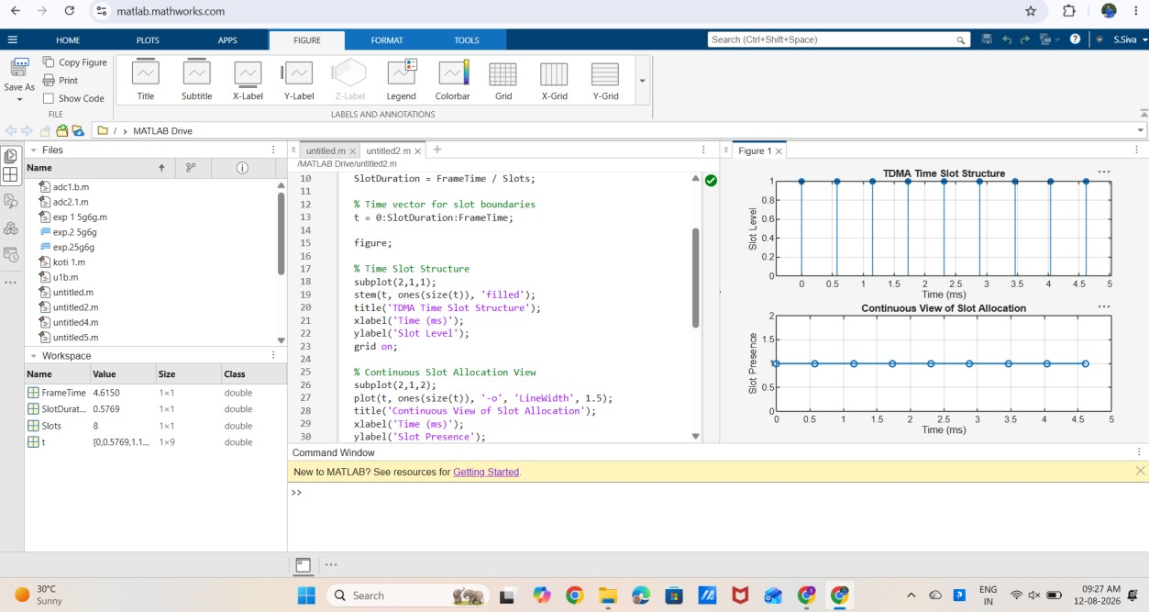

Result:
The graph shows discrete time slots arranged in a GSM TDMA frame structure with equal spacing.
• It confirms fixed time division where each slot is allocated a specific time interval without overlap.

